WORKSHEET 7
Module 3 – Search Engine Marketing

Get On the Map

» Instantly Boost Your Practice’s Visibility with Google Places
Getting “on the map” - or found by your target market - is a struggle for about 30%-50% (and in some areas up to 80%) of veterinary practices. Contributing to this state of affairs is the fact that many practices are totally unaware of their lack of visibility on a vital Internet resource – namely Google Places. What’s more, many practices don’t yet fully appreciate that unless they verify their data on Google Places, there could be potentially inaccurate, and thus damaging, information floating around the web about their business. Given that this information is being seen by hundreds, even thousands, of prospects every month, making certain that it accurately reflects who they are as a practice is paramount or else it may be misguiding potential clients and negatively impacting the practice’s reputation (and new client attracting / current client retention).

Not surprisingly, it is often those practices who most feel the pinch (in the form of diminishing new client numbers and lower retention rates) that are not fully utilizing this superb practice growth tool. And this of course makes sense – it is precisely here (Google Places) where prospects go first when searching for a veterinarian, so it follows that if a prospect can’t find your practice online, then they won’t have the information they need to get to your practice in person.

If you have yet to verify your Google Places page, please follow these simple steps EXACTLY as directed. These steps are proven Google Places techniques that will not only direct you on how to claim your listing, but will also ensure your listing is optimized to the best of its ability. If at any point you begin to feel this is getting a bit esoteric for you, by all means ask for help. Just do it soon, because every day that your online position is overlooked is another day potential clients are missing you and undermining your practices growth potential.

» Creating a Google Account
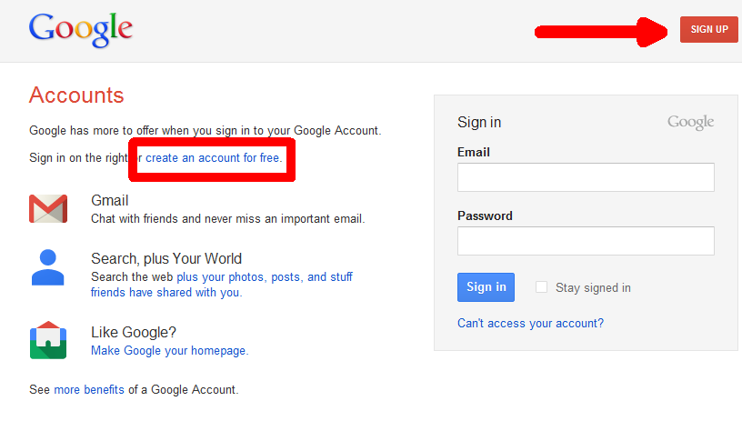
- Go to http://www.google.com/accounts.
- Click the ‘Sign Up Now’ button.
- Follow the directions on the page.
- Go to the email address you provided and click the verification link sent by Google.

» Adding a Business Listing
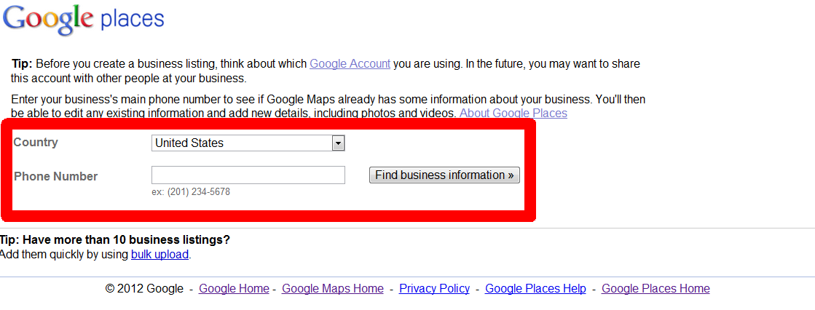
- Go to http://places.google.com/business.
- Click the button ‘List Your Business’.
- Enter your business phone number in the phone number field.
- Your practice should appear. If it does, click the Edit link. If your practice does not automatically appear, you will be asked to begin inputting your listing.

» Inputting Business Information
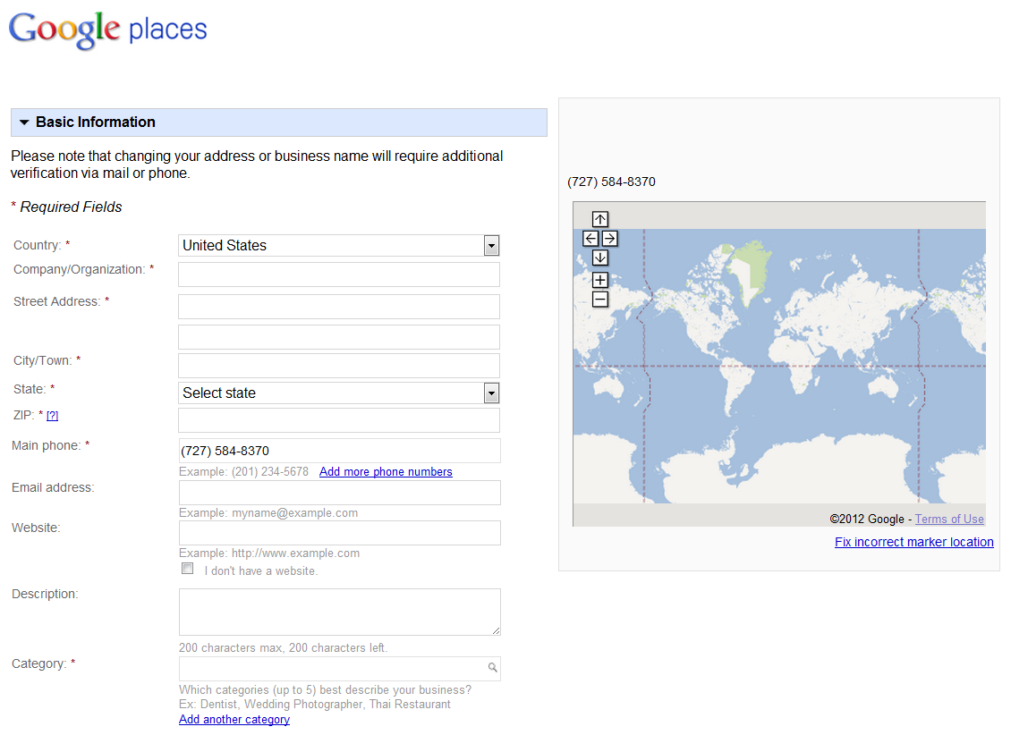
- Company Name: Add your actual practice name.
- Phone Number: Be sure to use a local phone number (no 800 numbers).
- Email Address: Should be the same domain as your website. If you do not have this, you may use a generic email address, however it is an important best practice to have your own domain with your own email address (e.g. rather than abcvetclinic@hotmail.com yours should be drjoe@abcvetclinic.com).
- Description: You should spend time on this section. You only have 200 characters in which you must include keywords (such as “veterinary”, “vet”, “clinic”, “animal hospital”, etc.) AND your city or area (neighborhood) name. This description must be appealing for potential clients searching for a local veterinarian - the objective is to make your practice appear as engaging and personable as possible.
*CAUTION: only one or two keywords should be used in this section
- Ex. The enduring love of animals guides the skillful hands of every member of the ABC Animal Hospital veterinary team here in [city name]. New clients receive [Unique Selling Proposition]. Call XXX.XXX.XXX to book your appointment.
- Ex. We view each of our patients as the most important animal in the world! This has been the ABC Animal Hospital’s approach to veterinary medicine here in [city name] for over xx years so Call XXX.XXX.XXX to book your appointment today!
- Ex. Love your pet? We know the feeling! At ABC Animal Hospital our passion drives our veterinary team here in [city name]. Join our family of over 3000 pet owners by calling XXX.XXX.XXX today!

- Category: You have 5 categories available. Be sure the first two are ‘Veterinarian’ and ‘Animal Hospital’. The other three could be anything you feel is best such as ‘Veterinary Clinic’, ‘Kennel’, ‘Pet Groomer’, ‘Pet Store’, etc.
- Service Areas: Only an issue for vets that service a niche area such as equine, large animal, or house calls. If this applies to you, check the ‘YES’ bubble and enter the radius of the area you serve. If your business address is not somewhere you’d like clients to know about (such as your home) then be sure to check the box ‘Do not show my business address on my Maps listing’.
- Hours of Operations & Payment Options: Be sure that these are filled in correctly as Google rewards completeness and customers will be reviewing your practice’s hours of operations carefully.
- Photos: It is important to add at least 3-5 photos to your Google Places listing. The first photo will be used as the listing icon so it should be emotionally captivating - you want to grab the attention of the prospective client. You do not want to use just a picture of your sign or facility. Instead try a picture of one of your vets or staff holding a puppy or some other evocative image portraying ‘cuteness’ and emotion. The first image you upload is the most important as this image will be shown within the search engine results so ensure that it is compassion focused.

Below are images that DVMelite has purchased the license for on your behalf. Simply click the link, right click the image on your screen, save it to a folder, and then upload it to Google Places.

http://www.panoramio.com/photo/70084546

http://www.panoramio.com/photo/70084548

http://www.panoramio.com/photo/70084552

http://www.panoramio.com/photo/70084553
- Video: Google will reward your listing if you have a video. Upload a video from your personal collection or if you do not have one, check YouTube for a video you deem appropriate. One powerful strategy is to create a video of the primary veterinarian, introducing the clinic and sharing the inspirational vision behind the practice. Below I have included generic videos that you can use in the short term in order to complete your Google Places listing efforts.
- Ex. http://www.youtube.com/watch?v=S-pYM4VVNaI (source: dvm360)
- Ex. http://www.youtube.com/watch?v=nbi2Fsj95Ik (source: dvm360)

- Additional Details: This is the final area that you should pay careful attention to. In this section you can add a subject on the left and then a response on the right. Be sure to include:
  - Statements about your clinic using positive wording. (N.B., ensure to abide by local association guidelines on allowable language.)
  - Links to your website, social media pages, and client forms.
  - Keywords such as veterinarian, veterinary clinic, and ‘geo modifying’ terms such as your city name, primary area name and surrounding areas (although don’t overdo this, as there is a fine line of placing appropriate keywords and then placing too many keywords).
  - Differentiating factors of your practice.
» Example: Additional Details
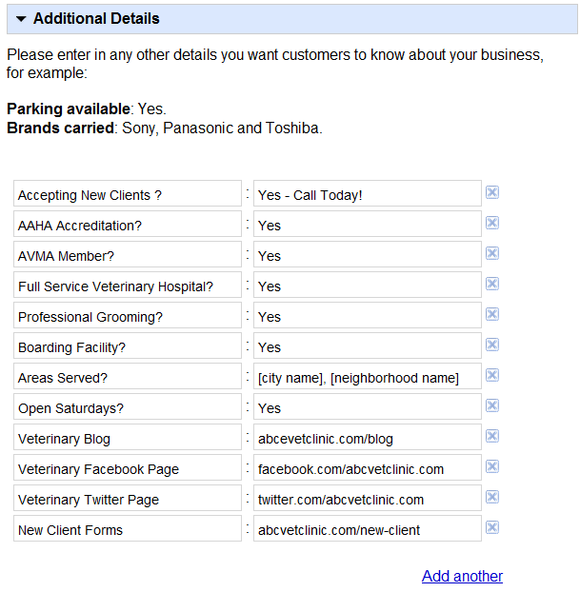
- Submit: Click the Submit button once finished.
- Verification: You can verify your account either by telephone (if you have easy access to the phone) or by post. Both methods will deliver to you a 4 digit pin number which you will enter in the Google Places interface dashboard to confirm that you are indeed the business owner.

» Offers
*Offers have been discontinued for businesses outside the United States as of May 31st 2012
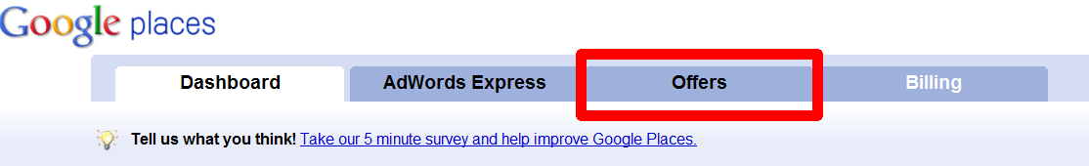
- Offers: Once your Google Places has been verified (by either phone or mail), you will be able to add Offers. Offers expire every 30 days, but provide a free method of targeting prospects within Google Places and on Google Maps.
  - To create an effective offer ensure:
  - The language is compelling (see examples below)
  - An eye catching image is used (considering using images from above)
  - Ensure you update your Offer every 30 days (otherwise they will expire and disappear).
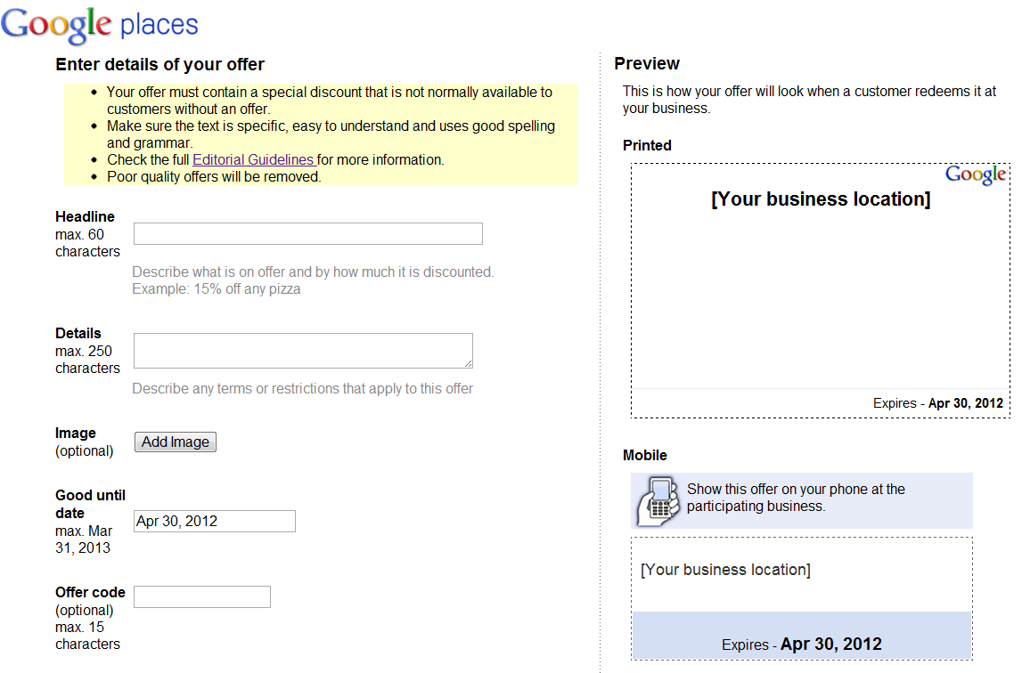
» Final Remarks:
I would recommend implementing this process as soon as possible. Google Places is very important component of your online presence and it ought to be both verified for accuracy and optimized to convey a message that reflects what you work so hard to provide within your practice. And remember: the more complete your profile is, the more likely it will be rewarded with a higher position within the search engines. Lastly, it is important to note that it may take several weeks for the changes you make to your Google Places Page to be recognized by the search engines – so get started now!
Final Checklist:
- Description is compassion focused with call to action & phone number
- 5 categories have been added
- 1st image is engaging and compassion focused
- 3-5 images uploaded
- 1-2 videos added
- Links to your website & social media added in “Additional Information”

Questions?
Please feel free to email: phpjumpstart@dvmelite.com

